**Receive data**

There are two parts involved in this use case:The client sends instructions and is processed by the edge server.The edge server transfers the processed data to the central server.The command mode is used by the client to send instructions to the edge server

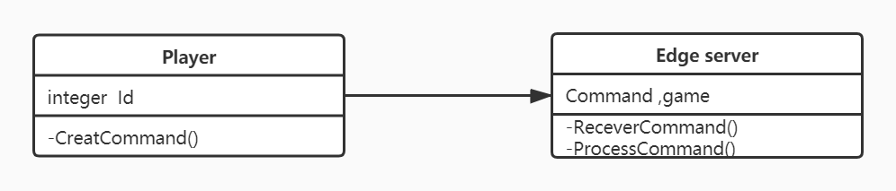

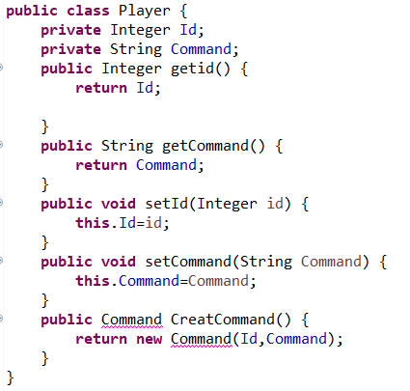

Edge Server Class

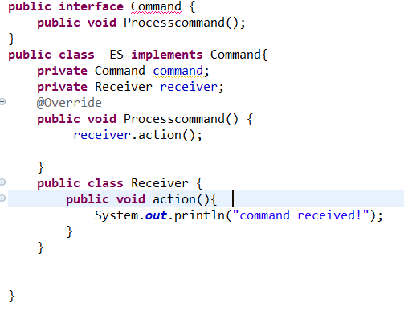

**upload data**

This part of the edge server uploads the processed data to the central server and stores these changes

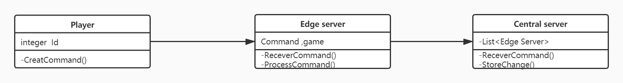

**public** **class** Central {

**private** List Edge Server;

**private** Change change;

**public** StoreChange(Change change) {

**this**.Change =change ;

}

**public** Change getChange() {

**return** change;

}

**public** **void** setChange(Change change) {

**this**.change = change;

}

}